Black Swans and Grey Swans: Navigating financial risk with AI-driven predictive analytics

Introduction
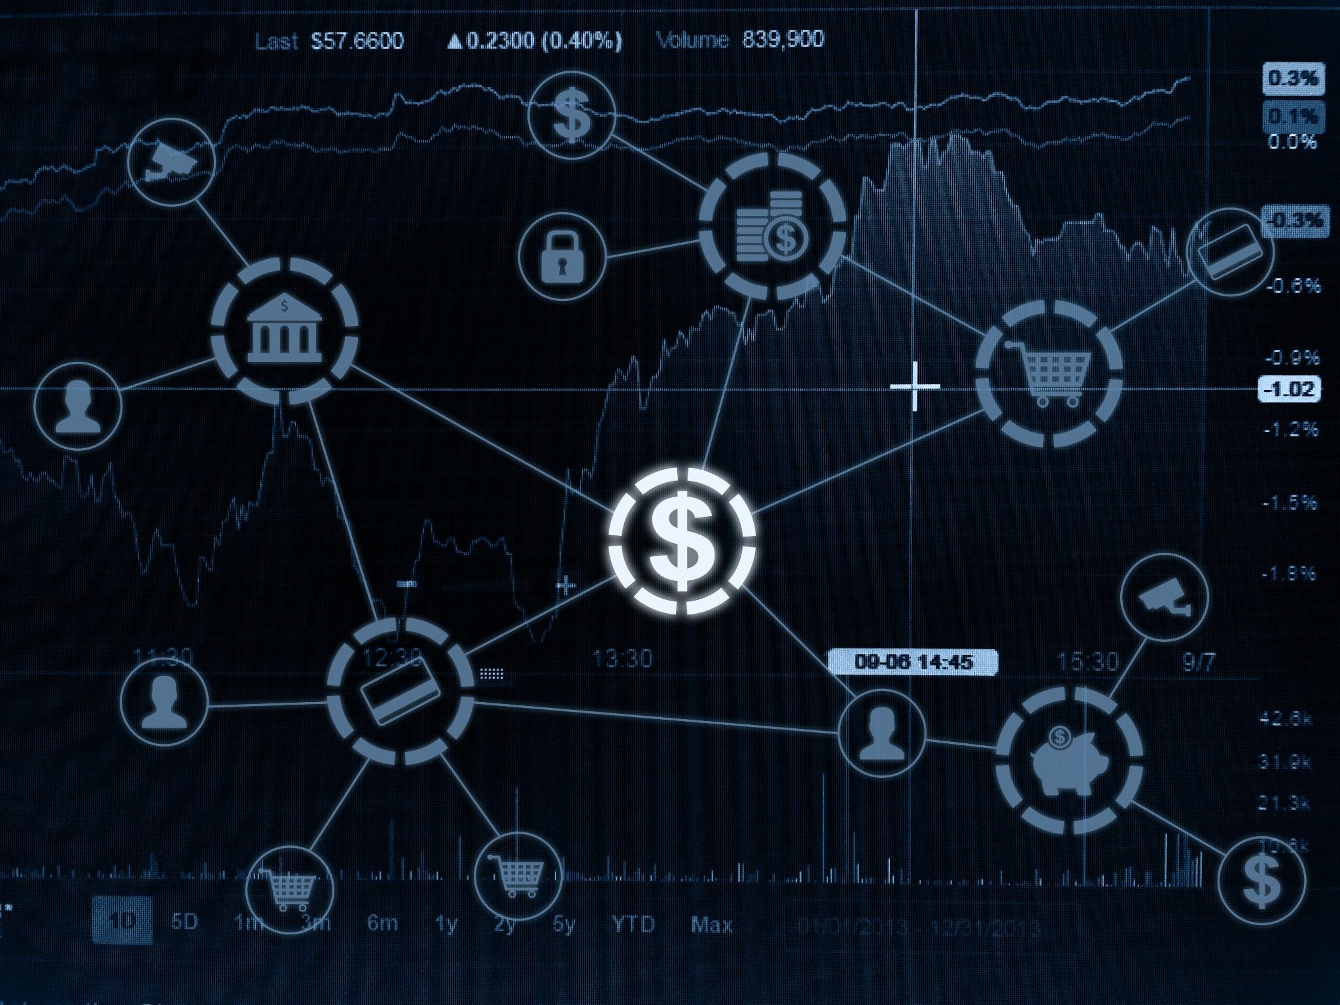 | In the increasingly interconnected global financial landscape, businesses and risk managers face a challenging environment that encompasses a range of risks from predictable and manageable to unpredictable and catastrophic. The concepts of black and Grey Swans emerged from post-event analysis to help explain the impact of major, disruptive events, especially events that disrupt economies, financial systems, and markets.  South African businesses face volatility on multiple fronts. Domestically, persistent structural constraints, energy instability, a deepening water crisis and uneven growth continue to erode operational resilience. Externally, the global environment has become more unpredictable: shifting trade alliances, sanctions regimes, conflicts affecting critical shipping routes, and renewed competition among major powers all shape capital flows, commodity prices, and investor sentiment. While local institutions have generally maintained strong capital buffers and profitability, the ripple effects of global policy shifts, such as evolving tariff structures, supply-chain realignments, and tighter global financial conditions, are exerting indirect pressure on funding costs, credit quality, and liquidity.  Given this exposure to both domestic and international volatility, risk managers must refine their approaches. Integrating the shocks of black swan events and the more foreseeable grey swan events into their risk management frameworks is essential, and cutting-edge technologies like AI-driven predictive analytics can help address these challenges.

Understanding Black Swans vs. Grey Swans

Black Swans
The term Black Swan, coined by Taleb in his book The Black Swan: The Impact of the Highly Improbable (2007), describes risk events that are extremely rare, carry severe consequences, and appear predictable only in hindsight. The term referred to the incident when Dutch explorer Willem de Vlamingh encountered black swans in Australia in 1697, disproving the long-held European belief that all swans were white.
These events fall outside conventional forecasting models, and when they occur, often force a reassessment of risk assumptions. Taleb urged decision-makers not to rely too heavily on historical data and conventional statistical models, and to build robustness against outlier events rather than attempting to accurately predict them.


Grey Swans
Grey Swans are less extreme in their impact than Black Swans and refer to events that are rare but somewhat predictable. They occupy the middle ground between foreseeable White Swans and the unpredictable Black Swans.
Grey Swans are slow-burning events whose impact and consequences unfold over time. Political decisions, regulatory shifts, demographic pressures and structural economic imbalances are all typical examples. Early signals tend to be faint and rarely conclusive, making them easy to ignore, especially when organisational culture rewards short-term thinking, confidence in existing models is high, cognitive biases come into play, or monitoring keeps returning ambiguous results.

The inter-connectedness of Black Swans and Grey Swans
Grey Swans matter because the most destructive Black Swans are often Grey Swans that were ignored. They are born of a collective failure to appreciate the potential for known, low-probability risks to converge, accelerate, and trigger systemic consequences far more extreme and widespread than the initial individual risks would suggest. Assessing individual risks in isolation isn't enough. We need to understand how they interrelate through links that can take decades to form, and then have the foresight to identify and prepare for situations in which these risks merge and create a catastrophic and surprising Black Swan event, as seen in the examples below:


The rapid expansion of AI and the emergence of an AI‑driven credit bubble (2026)
The acceleration of AI adoption has drawn hundreds of billions of investment dollars from hyperscale cloud providers and sovereign wealth funds into semiconductors, data centre infrastructure and cloud computing ecosystems, as firms compete to secure the capacity needed to support this trend. While there is tangible technological transformation, two trends reflect those that preceded past periods of financial exuberance, such as the 2008 global financial crisis, they include the concentration and pace of investment, and the fact that valuations in AI‑exposed firms are being priced in long‑dated, near‑perfect growth trajectories.
Early indicators of the concentration and pace of investment, and a looming crisis or bubble, include:
- The proliferation of AI‑themed exchange‑traded funds (ETFs) that funnel capital into a narrow set of dominant technology platforms and semiconductor manufacturers.
- Private‑credit funds offering leveraged financing to data‑centre developers and AI start‑ups with untested business models.
- Increasingly complex investment structures are bundling AI‑linked cash flows in ways that obscure underlying risk. These include revenue‑sharing agreements, long‑dated compute‑capacity contracts, and project‑finance vehicles. Although these instruments are not yet as opaque or widespread as those that fuelled the 2008 crisis, the trajectory is towards driving leverage, concentrating exposures, and complex financial engineering built on optimistic assumptions.
The risk is further compounded by the ecosystem’s interconnectedness and the growing assumption that exponential growth can continue uninterrupted. If the industry’s growth is disrupted by events such as infrastructure damage, a slowdown in AI adoption, regulatory intervention, or semiconductor supply chain disruptions, it would affect hyperscale capital expenditure plans. As the expenditure plans are downscaled, it would impact chipmaker and equipment supplier revenues. Lower revenues would put the repayment of commitments to leveraged infrastructure financing vehicles at risk. If these vehicles have been bundled together, the equity investors, private‑market funds, and lenders will be exponentially exposed to the same AI‑centric risks resembling the systemic contagion of 2008.
Without properly challenging the underlying assumptions of the AI expansion, conservative underwriting, more transparent disclosure on concentration risk and underlying assumptions of investment models, and closer monitoring, the AI super cycle could shift from a powerful innovation engine to a Grey Swan and ultimately a Black Swan event.

Geopolitics, trade fragmentation, and the shifting global order (2025 - 2026)
Geopolitical rivalry, supply chain realignment and energy market instability are causing a structural shift in the global trading system. This has been accentuated by the United States adopting a more assertive, protectionist economic stance, introducing a punitive tariff regime against countries it feels are not aligned with or are hostile towards the USA.
Recent conflicts in the Middle East and the ongoing Ukraine-Russia conflict have driven up freight costs, disrupted supply routes and fed volatility in energy markets. Each of these pressures has been visible for years in isolation, qualifying them as Grey Swans, but their convergence has produced a level of systemic fragility that could tip into something far more disruptive if geopolitical tensions deteriorate further.
Confidence in the US-led financial system has also grown more fragile. Persistent fiscal deficits, political gridlock and recurring instability in Treasury markets have raised serious questions about long-term debt sustainability. Dollar cycles have become harder to read, with bouts of weakness reflecting growing unease about the weaponisation of the currency, the scale of US borrowing and the vulnerabilities exposed in global supply chains. A growing number of countries, particularly within BRICS, and oil-producing countries such as Iran, have begun settling trade outside the dollar, suggesting a gradual but deliberate diversification of global payment arrangements.
There is a slow drift toward a multipolar financial order. Dollar primacy is eroding as trade is increasingly settled in other currencies and energy supply is being politicised. Markets are pricing in fiscal and geopolitical risk, placing the US Treasury under strain. Trade blocs are emerging around politically aligned partners.
South Africa faces a mixed bag. On the one hand, oil price and US Dollar volatility and market stress complicate the country's funding conditions, raise import costs and add to inflationary pressure. On the other hand, there are opportunities. Dollar weakness has historically pushed capital into emerging markets as investors seek yield. South Africa tends to benefit from this, with stronger demand for local bonds and equities supporting the Rand and easing short-term funding costs.
The current US stance towards the rest of the world has lent greater strategic weight to South Africa's mineral reserves and logistics infrastructure. Its deposits of platinum-group metals, manganese, vanadium and rare-earth-adjacent minerals make it a meaningful supplier for energy transition industries. Regional corridors, including the North-South Corridor, the Maputo and Walvis Bay routes, and emerging rail rehabilitation partnerships, strengthen its position as a conduit for mineral flows from across Southern Africa. As manufacturers and commodity traders look to reduce dependence on single-country supply chains, these corridors offer an attractive combination of routing alternatives, resource access and relative political neutrality. In addition, the growing and existing tensions around the Suez and Panama Canals bode well for increased shipping volumes around the Cape of Good Hope.

COVID-19 pandemic (2020)
Although pandemics are not new, the global scale and speed of the COVID-19 outbreak were unprecedented. Businesses faced challenges ranging from loan defaults to operational disruptions, highlighting the need for robust preparedness measures. Public-health experts had long warned of a novel coronavirus leap from animals to humans; SARS (2003) and MERS (2012) were clear warning signs. However, the sheer speed of global spread, societal lockdowns and economic fallout was a completely unexpected shock, hallmarks of a Black Swan. The underlying drivers were known (Grey Swan), but the scale and interconnected-system contagion crystallised with the kind of visceral shock normally reserved for Black Swans.

The 2018 Turkish currency crisis
The crisis unfolded amid political uncertainty, erratic central bank policies, and external economic pressures, resulting in a rapid depreciation of the Turkish Lira and substantial market volatility. Though recognised by some as a potential risk, the depth and suddenness of the crisis surprised many investors, underscoring that while Black Swan events are rarely predicted outright, the integration and monitoring of diverse data streams can provide early hints that certain stressors are converging in a way that merits pre-emptive caution.

The 2008 global financial crisis
In hindsight, many of the risk factors that precipitated the financial crisis were visible: mounting subprime mortgage defaults, unchecked growth in complex financial derivatives, and widening credit spreads. Analysts had been warning about the mismatches in loan practices and the vulnerabilities inherent in the securitisation process. These signals, however, were either downplayed or not cohesively integrated into risk models.
Thus, while the scale and systemic contagion of the 2008 crisis struck the markets with a shock usually associated with Black Swan events, a deeper look reveals that many of its elements were, in fact, foreseeable, qualifying it as a Grey Swan event in many respects.

Managing Black Swans down to Grey Swans
Grey Swan events occupy the middle ground between everyday risks (White Swans) and completely unforeseen events (Black Swans). Their precursors exist but are often so subtle that traditional monitoring may overlook them, resulting in Grey Swans becoming Black Swans.
There is optimism that, as AI-driven predictive analytics and advanced technologies mature, future risk managers might be able to detect these subtle early indicators of events that were traditionally deemed unpredictable. Modern AI platforms can analyse vast and heterogeneous datasets, ranging from structured financial numbers to the sentiment expressed in global news narratives, with much greater speed and nuance than human analysts could manage.
Considering these advancements, the traditional notion of the Black Swan, as a surprise with no identifiable precursors, might be destined to lose relevance.

Enhancing Grey Swan detection through AI-driven analytics

The value of using AI-driven analytics lies in using multiple technologies. AI and machine learning move analysis beyond the traditional by continuously synthesising vast, disparate datasets. It integrates structured data, such as market indices, credit‑default‑swap (CDS) spreads, and foreign‑exchange movements, with unstructured sources like news media, regulatory filings, and geopolitical intelligence.
Advanced anomaly detection algorithms can sift through these combined feeds to flag statistical outliers, such as the correlated rise in mortgage delinquencies and CDS spreads that preceded the 2008 Global Financial Crisis. At the same time, natural‑language‑processing (NLP) models provide contextual insight by tracking shifts in tone, frequency, and sentiment, for example, the surge in global references to “pandemic” and “outbreak” in late 2019 when the COVID-19 crisis was in its infancy.
If we use the 2018 Turkish Lira crisis to demonstrate the interplay between these technologies, we can see how much differently could have been managed. An AI model could have flagged the dangerous convergence of macroeconomic vulnerabilities like a widening current account deficit, as noted in IMF staff reports of the period, with a sharp increase in the cost of insuring against default (CDS spreads). Concurrently, its NLP component would have been analysing the escalating political rhetoric in the news and social media surrounding central bank independence and the diplomatic dispute with the United States. Could have quantified the real-time correlation between these qualitative political signals and quantitative capital flight, generating a stronger risk signal that isolated indicators had missed.
Unlike conventional models reliant on static thresholds, AI-driven models can create a dynamic, learning system that adjusts alerts in near real-time. The ultimate value of these models lies in converting complex, real-world noise into actionable intelligence, thereby empowering organisations to shift from a reactive to a proactive risk management posture by adjusting investment exposures, securing supply chains, or stress-testing portfolios against emerging threats.
To drive advanced detection, risk managers need to strategically identify relevant Preventative Key Risk Indicators (KRIs) and Post-event KRIs to monitor and analyse both the qualitative and quantitative data they receive from their data sources.

Key risk indicators: Preventative measures vs post-event remediation

Effective Grey Swan detection requires a balanced set of preventative KRIs to identify emerging vulnerabilities, and post‑event KRIs, to assess impact and guide recovery.

Preventative indicators
Key risk | Typical indicators
Macro-economic indicators | - Monitoring global GDP trends, inflation rates, and fiscal policies.
Geopolitical risk | - Analysing political developments and trade policies to identify potential disruptions. Early monitoring of changes in trade policies can signal emerging risks; sudden, aggressive policy changes may hint at potential volatility that can affect global markets.
Market sentiment | - Using sentiment indicators (i.e. equity market volatility), and news analytics to gauge investor and corporate confidence. Changes in these indicators can flag uncertainty or stress in international markets that may ultimately impact funding, liquidity, and investor sentiment.
Supply chain dependencies | - Tracking vulnerabilities in global supply chains that could propagate shocks.
Currency volatility | - Since external shocks like tariffs can lead to rapid currency devaluations or volatility, monitoring FX indicators is critical for managing cross-border exposures.
Loan portfolio quality | - Deteriorating credit quality (i.e. non-performing loan ratios) and liquidity metrics can be early markers of broader systemic stress, particularly in interconnected global financial systems.
Operational resilience | - Regular, dynamic stress tests that incorporate possible trade shocks and global policy shifts can help prepare organisations for potential disruptions before they fully materialise.
Country risk | - Rapid downgrades in a country’s credit rating, or a sudden jump in credit spreads.  - Emerging markets bond index spreads.  - USD‐ZAR sovereign spread.  - External-debt-to-GDP ratio.  - Political-risk gauges (election cycles, policy‐uncertainty indices) and % of operations in jurisdictions with recent sanctions, unrest, or policy reversals.
Concentration risk | - Sectoral exposure concentration indicators, such as credit or revenue exposure to dominant sectors % of total revenue or lending to top sectors (e.g., mining, retail, agriculture).  - Counterparty dependency indicators, measuring reliance on a small number of clients, suppliers, or funders for example top 5 clients/suppliers contribute >30% of revenue or procurement.  - Third-party concentration risk indicators, assessing reliance on critical outsourced services such as % of IT, logistics, or compliance functions outsourced to single vendor.  - Geographic concentration of exposures can also be monitored i.e. cross-border exposures by country (e.g., neighbouring states, commodity-export markets).
Technology AI‑related risk | - Exposure to AI‑linked sectors (semiconductors, cloud, data centres).  - Dependency on single cloud providers or hyperscalers.  - Model‑drift frequency and algorithmic‑risk indicators in critical AI systems.
Liquidity and funding market stress | - LIBOR‑OIS (Overnight Index Swap) / SOFR‑OIS spreads, cross‑currency basis swaps, and repo‑market stress.  - Bid‑ask spreads and market‑liquidity depth in sovereign and corporate bonds.  - Reliance on short‑term wholesale funding.
Commodity and energy security risk | - Price volatility in critical minerals such as platinum‑group metals (PGMs), manganese, and vanadium.  - Tracking oil‑price shocks and shipping‑route disruptions.  - Monitoring energy‑supply stability and infrastructure capacity constraints.
Cybersecurity and digital resilience | - Frequency of cyber‑incidents, intrusion attempts, and ransomware alerts.  - Patch‑latency indicators and third‑party cyber‑risk exposure.
Climate and environmental risk | - Extreme‑weather disruption frequency.  - Water‑security indicators (dam levels, municipal supply stability).  - Carbon‑transition‑risk metrics.

Post-event remediation
Leveraging these KRIs in a post-event context enables risk managers and management to assess damage, allocate capital effectively, and implement corrective measures swiftly. Once a shock occurs, timely and actionable insights for remediation can be drawn from post-event KRIs such as:
Key risk | Typical indicators
Market impact | - Monitoring of trends such as sudden changes in interbank rates; Declining stock prices of financial institutions.  - Rapid shifts in investor sentiment, can reveal the immediate market reaction and liquidity shortages, helping organisations to implement rapid-fire contingency measures.
Credit quality deterioration | - Spikes in non-performing loans (NPLs) and increased loan loss provisions, can pinpoint impacted segments within the organisation’s credit portfolio, guiding both remediation and recovery strategies.  - Sector‑specific credit‑stress mapping.
Operational performance | - Performance deviations in operational metrics (e.g., cost-to-income ratios) or disruption in payment and settlement systems in the wake of an event can highlight areas where the shock has impaired business continuity, prompting corrective actions.
Capital adequacy and liquidity | - Monitoring rapid changes in capital adequacy ratios and liquidity outflows from core segments, post-event enables management to understand stress magnitude, recalibrate capital buffers, and adjust funding strategies accordingly.
Customer behaviour | - Observing customer behaviour can help identify if market shocks are leading to a loss of confidence, which may necessitate targeted communication and remedial customer engagement.  - The impact can be tracked through monitoring indicators such as changes in deposit flows  and shifts in customer transaction patterns.
Technology and cyber | - System downtime, data‑loss incidents, or AI‑model failures.  - Third‑party service disruptions affecting critical operations.
Reputational impact | - Negative media sentiment spikes, social‑media volatility, and stakeholder‑trust metrics.


Conclusion
AI and machine learning are not a substitute for sound risk judgment, but they represent a meaningful advancement in what risk frameworks can realistically detect and how quickly. The broader lesson from historical Black and Grey Swan events is that the underlying signals were rarely absent - they were missed, misread or never connected in time. More sophisticated tooling addresses part of that problem, but the organisational dimension matters equally: building the processes, governance structures and indicator frameworks that ensure what these systems surface is acted upon by those with the authority to do so. Organisations that invest in both will be better positioned to convert early warning into timely intervention, and to manage uncertainty with greater confidence as the risk landscape continues to evolve.

